**Best Tourist Attractions in the World**

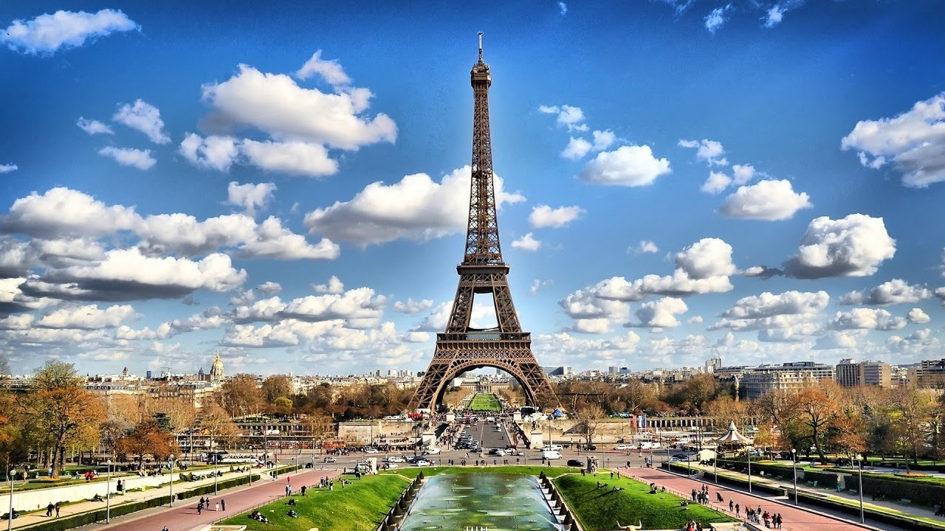

If you have been saving a long time for that holiday of a lifetime, but you are not sure where to go, then look no further. We have summarized three of the top tourist attractions in the world. Read, enjoy and then make your mind up!

**Macchu Picchu**

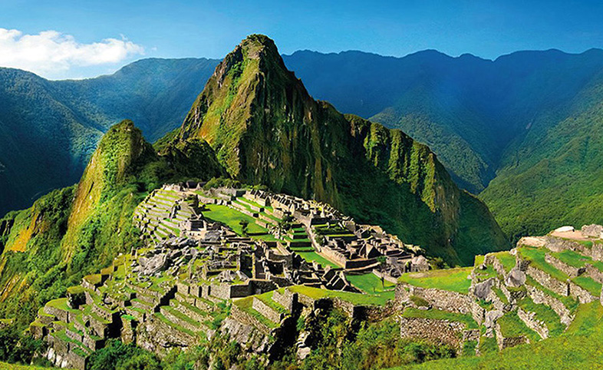

Situated in the Andes, and meaning “Old Mountain” the world’s most popular destination is the Peruvian UNESCO world heritage site at Macchu Pichhu. It was built in the 15th century by the Incas but later abandoned, possibly because of assaults by the Spanish conquistadors or through plagues brought by the Spanish.

For history buffs, two of the many interesting things about Macchu Picchu are that the buildings are astronomically aligned and the bricks have no mortar between them. There are many temples, terraces and water channels making up a beautiful and interesting area.

Things to Do

There are custom made holiday packages by local experts offering 24/7 support. An example of such a company is “Peru for Less”. You tell them [your travel plans](https://www.hindustantimes.com/travel/travel-tips-5-ways-to-plan-a-debt-free-vacation/story-azSyWI6LGhrHraoZ1IxqpI.html) and they work out an itinerary for you. This takes the strain and worries out of a trip to a country you have never been to and whose customs, language and food you may have no knowledge of.

If you are doing things “your way” and are not following a particular itinerary then the visitor could stay in one of the towns near Macchu Picchu and walk or take a bus up to the ruins.

Where to Stay

The Mama Simona Hostel in Aguas Calientes is 1.3 miles from the ruins. It is rated 5.0 on Tripadvisor and very reasonably priced. For a more luxurious stay, the SUMAQ Machu Picchu Hotel is also about 1.3 miles from the ruins and is rated at 4.5 on TripAdvisor. It is a Travellers’ Choice Winner 2018, with a Certificate of Excellence and GreenLeaders Bronze Level both awarded by TripAdvisor. It is expensive but is the number 1 hotel in Macchu Picchu in the TripAdvisor rankings.

Best Food and Drink in Macchu Pichhu

Mapacho Craft Beer & Peruvian Cuisine is rated no 1 in the TripAdvisor rankings for this area. It is situated just in Aguas Calientes a mile from the ruins. As the name suggests it specializes in craft beers and Peruvian food including quinoa rice and quinoa ice-cream!

**Angkor Wat**

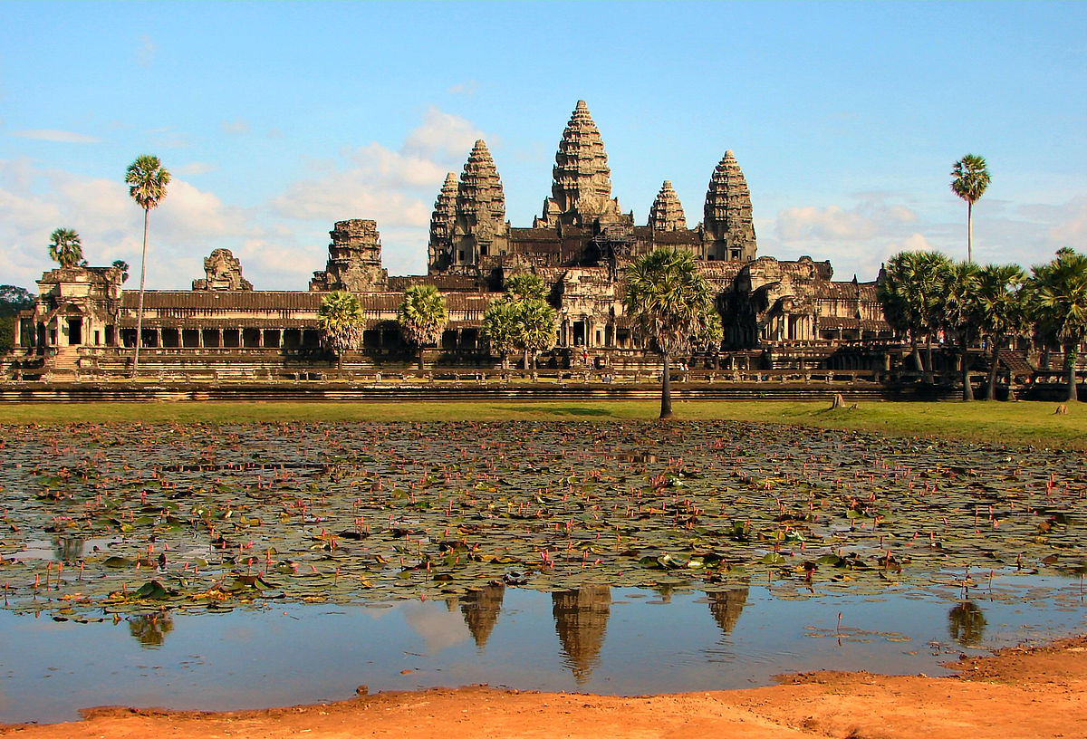

Angkor Wat is a temple complex covering 162.6 hectares in Cambodia and actually means “City of Temples”. It was built in the 12th century as a shrine to Vishnu, the Hindu god, but became a Buddhist temple later. From a distance, it looks like one big mass of stone and is in the shape of a lotus bud. However, as the visitor gets closer it can be seen to be made up of many towers, porches, and chambers linked by stairways.

Things to Do

It is advisable to see the famous Gallery of Bas-reliefs which is within the complex. This resides on the first level and within it, there are sandstone carvings covering 1200 square meters. All of the gallery walls, each 2m high, are covered top to bottom in carvings.

In the West Gallery, the Battle of Kurukshetra is displayed on the walls and is the story behind the [Hindu epic “Mahabharata](https://encyclopedia2.thefreedictionary.com/Mahabharata)”. There are many other galleries in the complex which are awe-inspiring and just magnificent to all who see them.

Where to Stay

The reasonably priced Popular Residence Hotel is ranked no 1 in this area by TripAdvisor. It is a Travellers’ choice Winner 2018 and has been awarded a Certificate of Excellence by TripAdvisor. It is in Siem Reap which is 20 minutes from Angkor Wat by car and 25 minutes from the airport. There is a free airport shuttle and shops close by. For a more luxurious experience, coming in at no 2 in the TripAdvisor rankings is the Jaya House, River Park. This is a lot more expensive but boasts an all-day restaurant, spa, and swimming pool and is situated on the Siem Reap River. It only takes 6 minutes to get to Angkor Wat by tuk-tuk.

Places to Eat and Drink

WILD, the “Creative Bar & Eatery” is ranked no 1 in TripAdvisor for this area. It is in Siem Reap on the Wat Damnak Road just over a mile from the ruins. It was opened in the summer of 2018 but has rapidly gained a top place after reviews of the food and drink with a 5-star rating the norm. The owners are a French couple who, according to the website, promise you can “drink and eat GOOD things in a lush garden under the stars”. The menu ranges from choices such as classic spring rolls to Caesar salads and then this can be washed down with a cocktail or two.

**The Taj Mahal**

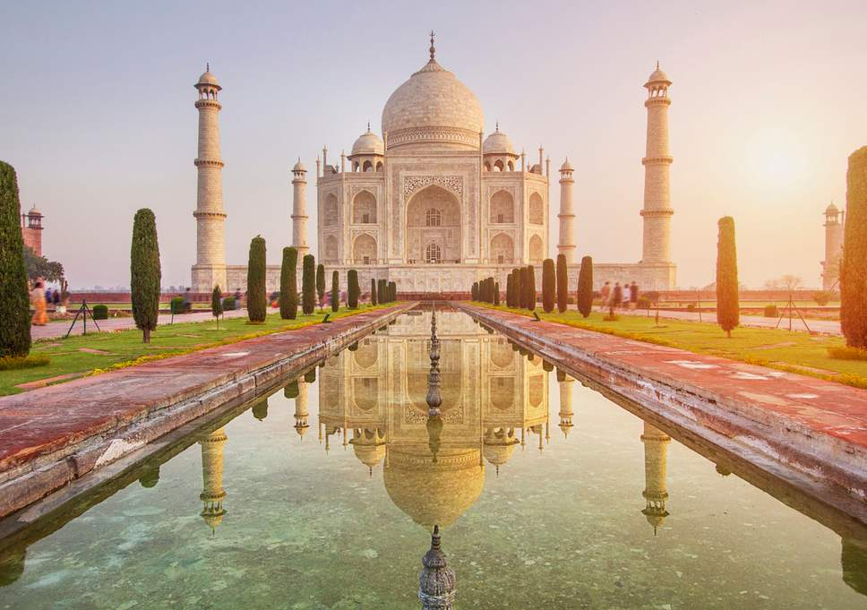

Who can forget Lady Diana and Prince Charles sitting on a park bench outside the Taj Mahal? It is one of the most poignant images over the last few decades speaking to us of a love lost. However, the Taj Mahal is an icon in itself. It is amazing to think that a building built to house the body of Mumtaz Mahal, the dead wife of Shah Jahan in 1632 is such a tourist attraction. It is a largely white, mausoleum built entirely of marble, and means “Crown of the Palace”. It was designated a [UNESCO](https://en.wikipedia.org/wiki/UNESCO)[World Heritage Site](https://en.wikipedia.org/wiki/World_Heritage_Site) in 1983. Remember in order to visit you must get an India e-visa.

To learn more about getting your India e-visa [click here](http://india-evisa.com/).

Things to Do

It is advisable to go between November and February when it is not so hot. Staying in Delhi and taking a day trip to the monument is a good way of seeing it. The Yamuna Expressway railway connects Agra, where the Taj resides, to Delhi and the train only takes 3 hours. It is also possible to go there by bus. There are the usual plethora of tours which will also take the visitor there.

It is open from 6 am to 7 pm apart from Fridays when it is closed for prayers. It is also open for night viewing around the full moon except for the month of Ramadan. There is an entrance fee for both day and night visits. Tickets can be bought online or at the gate. There is also a cheap app with an audio guide that can be downloaded which has been approved by the government.

Where to Stay

The Oberoi Amarvilas is a 5-star hotel and is ranked no 1 on TripAdvisor. It is literally 600m from the monument and the visitor can see it from their bedroom. It is decorated beautifully inside with white marble and [traditional fabrics](https://www.fibre2fashion.com/industry-article/2430/indian-traditional-fabrics). It is a Travellers’ Choice Winner 2018 for TripAdvisor and was awarded a Certificate of Excellence from them too. It has a fitness center, restaurant, and free shuttle service. Other awards include the “Top India Resort Hotel (Ranked 1st)” - Travel and Leisure, World’s Best Awards 2018.

The best budget hotel would be the Coral Tree in Amarlak Colony.

Places to Eat and Drink

The Bellevue and Esphahan restaurants at the Oberoi both offer a fantastic dining experience and are ranked highly. You will not be disappointed. However, on TripAdvisor, the no 1 restaurant is the MoMo Cafe which can be found in the Fatehabad Road. It serves both Indian and International cuisine.